Name:
Professor:
Course:
Date:
Arts of Africa on the Theme pf Government and Leadership
The exhibition show that will be conducted at this time of the year will focus on addressing the theme of government and leadership in the arts of Africa. Although African arts explore different themes, one of the themes that has been extensively explored is the theme of government and leadership, especially in the period before colonization. It is a common theme, especially in west Africa. Before colonization, there were different kingdoms, which were designed in a hierarchical manner. Different west African communities viewed leaders as semi-divine. Leaders played a critical role in controlling art. In particular, they controlled resources used to develop art, to ensure they possessed the luxurious and prestigious artifacts (Fraser and Herbert). Artworks like seats, clothing, and handheld objects were designed to distinguish leaders from ordinary people. Sculptures and other larger artworks were designed to show power and authority to the public (Clarke). There are other societies which were led by council of elders or associations. Art in these societies was designed to promote social control. They were used to give a visual form to spirits, whose power could maintain order and protect the community.
Exploring art in Africa, particularly government and leadership is one of the most interesting topics because, in addition to showing how the continent has developed over the years, it shows the different forms of leadership that are adopted. In Africa, art showing leaders, people in positions of power, and heroes was used to serve different functions, including political, commemorative, cultural, and spiritual functions. Sculptures, statues, and other artistic images were passed down from one generation to another, as a way of consolidating power and justify their positions to the public. People in positions of power used art as a medium to present themselves to their subordinates. Presenting themselves as semi-divine gave them a sense of intellect and superiority (Fraser and Herbert).
The objects that will be used to show this theme are,
- Queen Mother Pendant Mask (Iyoba), 16th century, Edo peoples, Court of Benin, Nigeria, ivory, iron, copper, 23.8 x 12.7 x 8.3 cm (The Metropolitan Museum of Art).
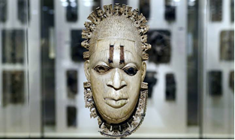
- Lidded Saltcellar (detail), Sierra Leone, Sapi-Portugese, 15th-16th century, ivory, 29.8 cm high (The Metropolitan Museum of Art).
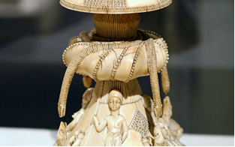
- Head of an Oba, Nigeria, Court of Benin, 16th century, brass, 23.5 × 21.9 × 22.9 cm (The Metropolitan Museum of Art).
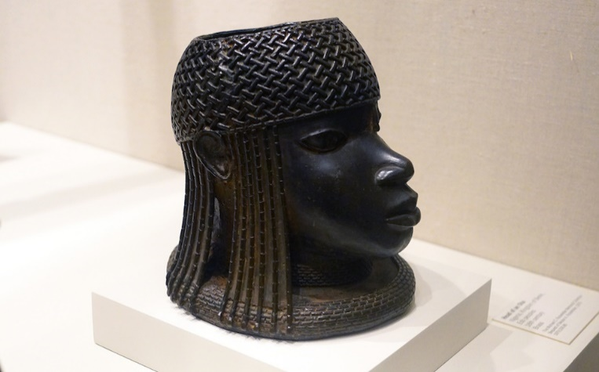
Each of these works of art excellently portrays power and leadership in the context of Africa, and how this power determined their lifestyles and those of their subordinates.
Queen Mother Pendant Mask shows government and leadership because of the material used; that is, ivory. Ivory was a precious and scarce commodity, which symbolized wealth and luxury. The use of iron inlays in the eyes also shows strength and authority on anyone who wore the mask. The Lidded Saltcellar also addresses the theme of government and leadership because of the use of ivory, the use of carvings to show elements of Portuguese traders, African warriors, animals, and lifestyle. The Head of an Oba explores the theme of leadership because it is a cast brass sculpture with elements of coral that idealized a king. The materials used were items of wealth, which signified Benin leadership. The sculpture has a rolled collar, which was associated with Benin rulers. There is an opening at the top, where an elephant tusk was fixed.

Works cited
Clarke, Christa. Lidded Saltcellar. (2006). https://www.khanacademy.org/humanities/art-africa/west-africa/sierra-leone/a/lidded-saltcellar
Clarke, Christa. Themes and issues in the art of Africa: Form and meaning. (2006). https://www.khanacademy.org/humanities/art-africa/african-art-introduction/themes-and-issues-in-the-art-of-africa/a/form-and-meaning
Fraser, Douglas, and Herbert M. Cole. African Art & Leadership. Madison: University of Wisconsin Press, 1972. Print.

